1. 绘制路网.net.xml文件

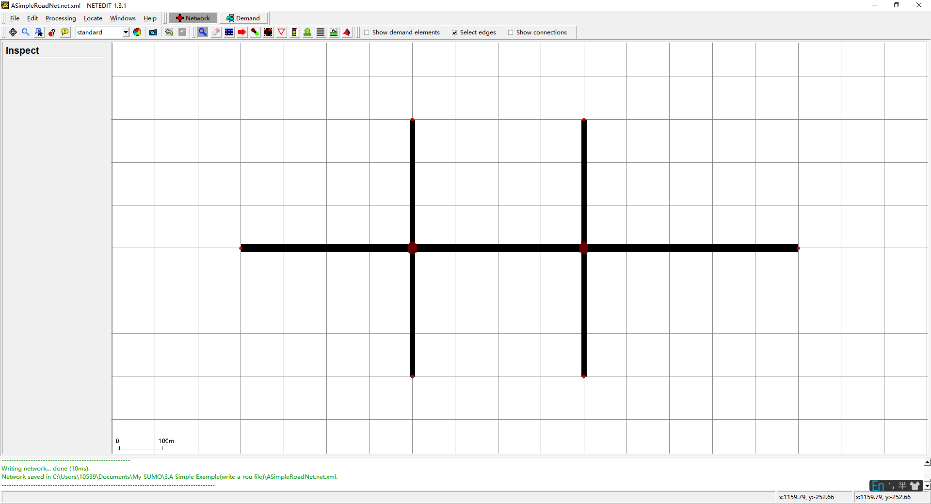

1. 构造.sumocfg文件

<input>

    <net-file value="ASimpleRoadNet.net.xml"/>

    <route-files value="ASimpleRoadNet.rou.xml"/>

    <additional-files value="signal_config1.xml;signal_config2.xml"/>

</input>

<time>

    <begin value="0"/>

    <end value="3600"/>

</time>

1. 构造.rou.xml文件

<routes>

    <routeDistribution id="routedist1">

        <route id="route0" color="1,1,0" edges="gneE7 gneE4 gneE10" probability="0.9"/>

        <route id="route1" color="1,2,0" edges="gneE7 gneE4 gneE12" probability="0.1"/>

    </routeDistribution>

    <vType id="t01" vClass="passenger" accel="0.8" length="5" maxSpeed="70" probability="0.8"/>

    <vType id="t02" vClass="truck" accel="1.8" length="15" maxSpeed="50" probability="0.2"/>

<vTypeDistribution id="typedist1" vTypes="t01 t02"/>

<vehicle id="110" type="typedist1" route="routedist1" depart="200" color="1,0,0"/>

    <flow id="ff0" from="gneE7" to="gneE10" type="typedist1" begin="0" end="3600" number="100"/>

</routes>

vType: 车辆类型，定义了车型比例

vTypeDistribution: 车辆类型分布

<flow ....../>定义了一个流，使用车型分布type="typedist1"

The following vehicle classes exist:

| **vClass** | **bitmask bit** | **comment** |
| --- | --- | --- |
| ignoring | - | may drive on all lanes regardless of set permissions. |
| private | 0 |  |
| emergency | 1 |  |
| authority | 2 |  |
| army | 3 |  |
| vip | 4 |  |
| pedestrian | 5 | lanes which only allow this class are considered to be 'sidewalks' in [netconvert](C:/Users/10539/Documents/My_SUMO/%E6%96%87%E6%A1%A3sumo_documentation/netconvert.html) |
| ****passenger**** | 6 | This is the default vehicle class and denotes regular passenger traffic |
| hov | 7 | [High-occupancy vehicle](https://en.wikipedia.org/wiki/High-occupancy_vehicle_lane) |
| taxi | 8 |  |
| bus | 9 | urban line traffic |
| coach | 10 | overland transport |
| delivery | 11 | Allowed on service roads that are not meant for public traffic |
| truck | 12 |  |
| trailer | 13 | truck with trailer |
| motorcycle | 14 |  |
| moped | 15 | motorized 2-wheeler which may not drive on motorways |
| bicycle | 16 |  |
| evehicle | 17 | future mobility concepts such as electric vehicles which may get special access rights |
| tram | 18 |  |
| rail_urban | 19 | heavier than 'tram' but distinct from 'rail'. Encompasses [Light Rail](http://en.wikipedia.org/wiki/Light_Rail) and [S-Bahn](http://en.wikipedia.org/wiki/S-Bahn) |
| rail | 20 | heavy rail |
| rail_electric | 21 | heavy rail vehicle that may only drive on electrified tracks |
| rail_fast | 22 | [High-speed-rail](https://en.wikipedia.org/wiki/High-speed_rail) |
| ship | 23 | basic class for navigating waterways |
| custom1 | 24 | reserved for user-defined semantics |
| custom2 | 25 | reserved for user-defined semantics |